Lost Item Detection Model

Model Overview
For the lost item detection model, an Artificial Intelligence model was developed using the YOLOv11 Nano (yolo11n) pre-trained model. Transfer learning was applied to fine-tune the model specifically for identifying objects commonly left behind in Shuttle. The dataset was prepared by annotating images into four distinct classes: Bag, Bottle, Laptop, and Umbrella. This supervised learning approach ensured that the model could accurately distinguish between various personal belongings under different environmental conditions.

Dataset and Training
The dataset was created using 5 real shuttle videos. Frames were extracted using roboflow. The model was trained using a dataset of approximately 1074 annotated images, which were augmented to improve generalization. The final dataset consisted of 940 training images, 90 validation images, 44 test images. The training process was conducted for 100 epochs on Google Colab using a T4 GPU. By utilizing a high number of epochs for a relatively small dataset, the model was able to learn intricate patterns and features of each item class effectively.

Model Performance and Accuracy
The trained YOLOv11 Nano model achieved strong performance metrics, ensuring its suitability for real-time safety and monitoring applications.
Overall metrics:
Precision (P): 0.902
Recall (R): 0.821
mAP@50: 0.904
mAP@50-95: 0.752

Interpretation:
mAP@50 = 90.4% → Excellent
mAP@50-95 = 75.2% → Very good

Class-wise Performance:
Class Precision Recall mAP50
Bag 0.958 0.787 0.917
Bottle 0.992 0.938 0.977
Laptop 0.902 0.875 0.951
Umbrella 0.987 0.840 0.887

The results confirm that the model is capable of accurately identifying lost items in real-time within a bus environment.

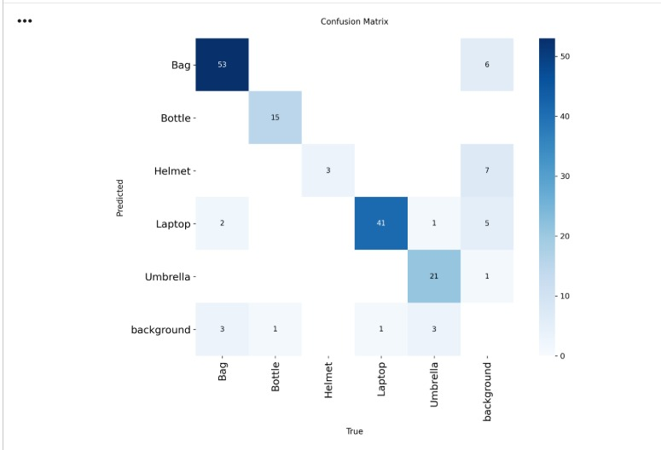
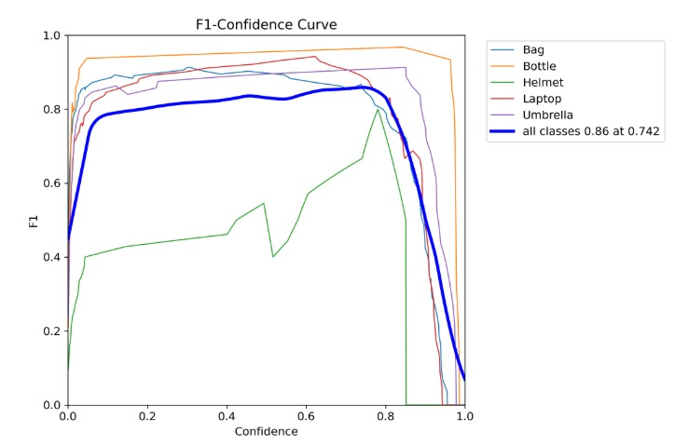
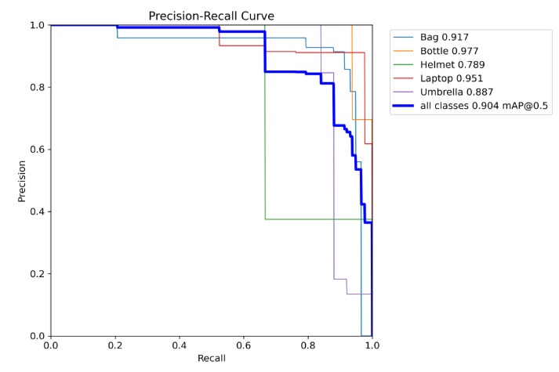

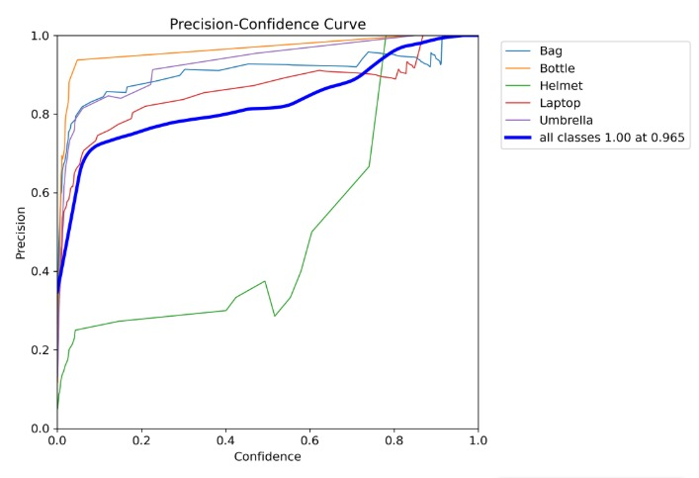
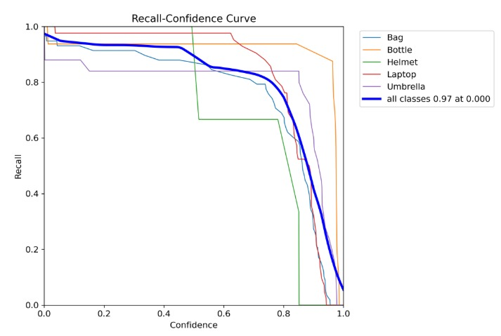

Item detection Outputs
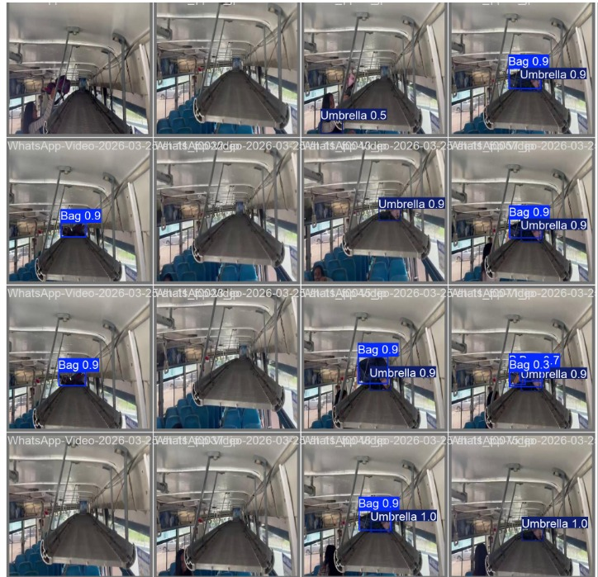

Backend and Frontend Integration

After the training phase, the best-performing weight file, best.pt, was integrated into the system’s backend. The integration workflow functions as follows:
- Conditional Processing (Passenger Density Check): The backend monitors the passenger count in real-time. To optimize resources, the object detection engine remains in standby mode and only activates when the passenger count reaches 0.
- Item Detection: Once the bus is empty, the system automatically opens the camera feed and utilizes the YOLOv11 model to scan the cabin for items belonging to the defined classes (e.g., Bag, Bottle).
- Database Synchronization: When a lost item is identified, the backend logs the detection details—including the item type and timestamp into the Firebase Firestore database.
- Student Claim Portal: The detection results are immediately visible on the Student Mobile Dashboard. Students can browse the list of identified lost items and submit a Claim Request for any item they recognize as their own.
- Admin Verification & Approval: All claim requests are sent to the Admin Dashboard's Requests Section. The administrator reviews the claims and has the authority to Accept or Reject each request based on verification.
- Status Update: Once the admin takes action, the status is updated in real-time across the system, notifying the student whether their claim was approved for collection.

